Wednesday, February 24, 2021.

**Unit 9: What are you wearing?**

**LESSON TWO**

**1. Listen to the story and repeat. Act.**

**2. Listen and say.**

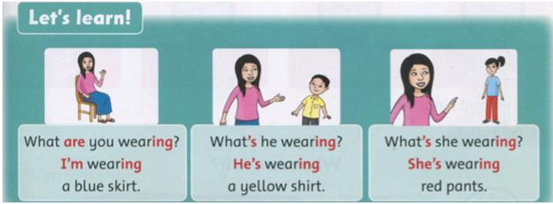

**Script:**

What are you wearing? => I'm wearing a blue skirt.

What's he wearing? => He's wearing a yellow shirt.

What's she wearing? => She wearing red pants.

**Dịch:**

Bạn đang mặc gì? => Tôi đang mặc váy màu xanh nước biển.

Anh ấy đang mặc gì? => Anh ấy đang mặc áo sơ mi màu vàng.

Cô ấy đang mặc gì? => Cô ấy đang mặc quần dài màu đỏ.

**3. Look and say.**skirt/ jeans/ boots/ shirt

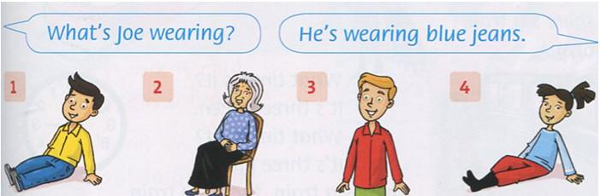

**Hướng dẫn:**

2. What's grandma wearing? =>She's wearing black skirt.

3. What's Tim wearing? => He's wearing red shirt.

4. What's Milly wearing? => She's wearing red pants and black boots.

**4. Look again and write.**

2. What's Joe wearing?

He's wearing blue jeans.

3. What's Grandma wearing?  
_____ a black ____.

4. What's Tim wearing?

_____ a red_____.

5. What's Milly wearing?

____ black____.

**Hướng dẫn:**

2. She's wearing a black skirt.

3. He's wearing red shirt.

4. She's wearing red pants and black boots.

NGUỒN GIẢNG DẠY:

https://vndoc.com/

https://www.youtube.com/